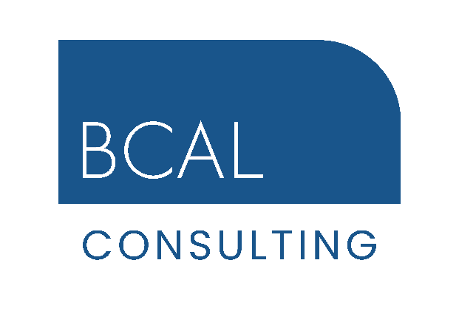
Graduate Civil/Structural Engineer
Summer 2024
£25,000 salary plus benefits
Wellingborough, Northamptonshire
bcal@bcal.co.uk
01933 440024

Position Overview
We are seeking an enthusiastic individual to embark on a rewarding career in civil and structural engineering with a focus on cutting-edge technologies such as BIM and Revit. The successful candidate will have recently completed their civil engineering degree and ready to receive comprehensive training to develop into a Chartered Civil or Structural Engineer

Key Responsibilities
- Collaborate and liaise with senior engineers on various civil and structural projects
- Assist in the preparation of technical design and drawings utilising Revit/Tekla design software
- Work independently to prepare technical documentation, check and reporting on progress
- Gain exposure to CDM (Construction Design and Management) regulations & Building Safety Act and contribute to the development of H&S and CDM documentation
- Conduct site visits/surveys (initially under supervision) to assess project requirements and progress
- Work with project teams to ensure timely and accurate project delivery, incorporating best practices
- Document controller of incoming and outgoing deliverables

Qualifications and Skills
- Minimum 2:1 in Civil/Structural Engineering degree (or similar)
- Skilled user of AutoCAD/Revit
- Good understanding and knowledge of Eurocodes
- Enthusiastic and committed individual with a strong interest in civil and structural engineering.
- Exposure or willingness to learn and apply new technologies.
- Knowledge or interest in CDM regulations and health and safety in construction.
- Excellent analytical and problem-solving skills.
- Strong attention to detail and a proactive approach to work.
- Ability to work collaboratively in a team environment.

What We Offer
- Comprehensive training and development to become Chartered Engineer MICE/MIStructE.
- Genuine opportunities for career development and progression
- Agile home and office working environment (Wellingborough)
- Paid professional membership subscription (1 per annum)
- Potential benefits after the various qualifying periods. Holiday purchase scheme, Discretionary Bonus scheme, Private Health Insurance, Permanent Health Insurance, Life Insurance, Employee Assistance Programme

How to Apply
Ring for an informal chat or email your CV and we will send you an Application Form to complete and return.
This is an exciting opportunity for the right individual who is looking for a career as opposed to just a job, within a company who are leaders in their field. Salary and benefits are negotiable for the right candidate, together with opportunities for further progression within the company.

